The auto camper rental  
 software

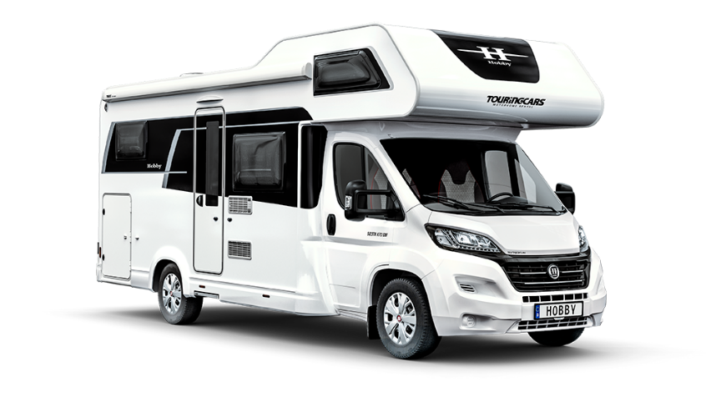

Computer Science- 2nd Semester training project

Hand in: May 7th, 2021

Supervisors: Karsten Skov, Tommy Haugaard, Frank Østergaard Hansen

**Authors: Andrej Simionenko, Raheela Tasneem, Fei Gu**

Contents,

1 Inception Phase 4

1.1 Start-up phase 4

1.2 Vision 4

1.3 Domain Model 4

1.4 Data dictionary 6

2 Elaboration Phase 7

2.1 Use Cases 7

2.1.1 Brief use cases 7

2.1.2 Fully dressed use cases 10

2.2 System Sequence Diagrams (SSD’s) 13

2.3 Prototype 15

2.4 ER Diagram 16

**Table of figures**

# Inception Phase

## 1.1 Start-up phase

The start-up phase begins with preparations of working environments for project and team. For the period of the project, it was early on decided to use zoom- break out rooms as well as discord server in order to hold daily meetings and communicate. There, the progress of the project as well as the next steps were discussed and shared.  
For collaboration between the team members, a Github repository was used in order to share and work together on java code and database, while draw.io program was used in order to create the diagrams. Additionally, for collection of information and report writing online google word document was utilized.

## 1.2 Vision

The team is designing and creating an administration and booking system for Wagner Families auto camper rental business. The system is created for rental of a fleet of auto campers, and it should be time-efficient and easily manageable for the Wagner family, modernizing the way they do business.

## 1.3 Domain Model

The domain model is a structured visual representation of interconnected concepts or real-world objects that incorporates vocabulary, key concepts, behavior and relationships of all its entities. In figure 1, the domain model of auto camper rental software is shown and is used in order to showcase the purpose of the software.

During the process of building a custom-made system, Domain model comes in especially useful in few different aspects. From the perspective of developers, the domain model helps to clarify and understand the real-world problems, that the customer is facing and offers an opportunity to discuss the requirements for the system. On the other hand, from the perspective of the customer, the domain model allows a more user friendly and not very technical picture of the upcoming system, as one of the draws of domain model is its visual simplicity. It must be stated that the conceptual classes in the domain model are not software objects, but more so representations of real-world conceptual classes.

For this project, a domain model using a UML class diagram notation was used. Straight lines connecting different objects showcase association. Thus…….

**Domain model here**

## 1.4 Data dictionary

The data dictionary is an agreement between the customers and developers over the concrete meaning of specific words used in the system. The dictionary is used to gain consistency and avoid confusion when specific words are used. Figure 2 shows a data dictionary for the auto camper system, where specific words are explained in further detail and their meaning in the system is set.

|  |  |  |  |
| --- | --- | --- | --- |
| **Name** | **Description** | **Alias** | **Format** |
| **Client** | Customer who is looking to rent camper | **Citizen/ client** |  |
| **Administrator** | Persons who manage & works at Camper renting company |  |  |
| **Bank** | Bank is responsible to hold an account as to receive payment from the client |  |  |
| **Deposit** | Client must pay 10% payment no later than 2 weeks after reservation. If the rental is cancelled for some reason – this deposit is lost. |  |  |
| **Discount** | client who come back year after year accordingly how many times they rent again, they get discount 5% or more |  |  |

# 2 Elaboration Phase

## 2.1 Use Cases

Use cases are written descriptions or event steps defining and documenting the interactions between actors and the system to achieve a goal. They are commonly used to represent a goal of a system and describe, clarify a single task of the process. Use cases can contain one or multiple scenarios, describing the order of events.  
The actors in the use cases can be humans, other users of the system, or the system itself. Description is used to explain a certain scenario, sequence of actions and interactions between the actors and the system.  
For the project two main types of use cases will be used: brief use cases and fully dressed use cases. The different types of use cases are used depending on how much detail is needed for certain scenarios.

## 2.1.1 Brief use cases

Brief use cases are used to see a short summary of all the requirements for the system. These use cases contain a short, one line description of the scenario between the actor and the system.  
Moreover, brief use case table is used to prioritize functionality of the program. The most important functions being at the top of the table, while not so important functionality near the bottom. This allows developers to focus on key functionality when creating the program.  
Figure 3 showcases brief use case table for the project. The use cases in the table are identified by a use case number in the first column, followed by the actor of specific use case in the second column, then in a third column use case description, the version in fourth column and finally a time estimate in the fifth. The use case number indicates the priority of the use case problem, thus the lower the use case number the more crucial it is. The actor column showcases who is the actor of the specific use case, while the description column gives a short summary. The fourth column, version, indicates in which iteration of the system the use case will be implemented. Lastly, time estimation is approximation of many hours a certain task is going to take per one developer. All this information is especially important for developers and the customers who are ordering a custom-made system. For developers it gives an estimate workload per task and allows an estimation of total time for the project. The total time estimate allows developers to calculate the approximate price for the project and inform customers.

|  |  |  |  |  |
| --- | --- | --- | --- | --- |
| Use case number | Actor | Use case description | Version | Time Estimation |
| UC1 | Admin | Create camper category | 1 | hours |
| UC2 | Admin | Create Contact | 1 | hours |
| UC3 | Client | Register user | 1 | hours |
| UC4 | Admin | Create Price Category according to facilities | 1 | hours |
| UC5 | Admin | Create Price Category in High & low seasons | 1 | hours |
| UC6 | client | Contact Camper Owner | 1 | hours |
| UC 7 | System | Create Confirmation email/invoice | 1 | hours |
| UC8 | Client | Confirm the email | 1 | hours |
| UC 9 | System | Create Rental payment | 1 | hours |
| UC 10 | System | Create Deposit | 1 | hours |
| UC 11 | System | Create Reservation | 1 | hours |
| UC 12 | System | Create Reminder | 1 | hours |
| UC 13 | System | Create insurance | 1 | hours |
| UC 14 | System | Create Discount | 1 | hours |
| UC 15 | Client | See Guidelines | 1 | hours |
| UC 16 | Client | Delete Review | 1 | hours |
| UC 17 | Admin | Delete Review | 1 | hours |
| UC18 | Client | Edit Review | 1 | hours |
| UC19 | Client | Give rating on Other Users(stars) | 1 | hours |
| UC 20 | Client | Accept terms of service | 1 | hours |
|  |  |  |  |  |

## 2.1.2 Fully dressed use cases

The fully dressed use cases allow to dwell deeper into the use case and inspect it completely. The use cases include all the details and steps needed for the action described to succeed. Two use cases were chosen to dwell deeper and fully explain the process that a new customer must go through in order to register in the system when completing an order. These use cases are use case 3 (Figure xx: Fully Dressed Use Case 3) and use case 8 (Figure xx: Fully Dressed Use Case 8), which can be seen bellow.  
To start off the registration process a new client must press the registration button when completing an order, making it the trigger event. The precondition is client selecting all the things that need to be booked. When the button is pressed, a new page is opened, where the user is required to enter a username and password, which are checked if they are valid and available. Afterwards, the clients’ full details must be entered, such as the name of the client, address, phone number, email and valid drivers license number. Once all the steps are done the system will send an email that must be confirmed by the client, making it the post condition. This is where the use case 8 – confirm email starts, making its precondition completing the registration form. In order to complete the registration, the client must open the received email, and press the confirmation button. Once the button is pressed, client gets informed that the registration is complete and the new account can be used, thus the post condition for this use case is completion of registration.

|  |  |
| --- | --- |
| **Use Case #3** | **Register user** |
| Actors | Client |
| Trigger | Search for registration |
| Precondition | The client has already searched for the camper and is ready to register |
| Postcondition | Confirmation of registration email is sent to the user |
| Normal flow | * The client enters username and password. * The system will check if the username and password are valid and available. * The client enters his info: name, address, phone No., email, driving license ID/No. * The system will send confirmation email. |
| Version | 1.0 |
| Date | 5-5-2021 |
| Author | Group: Fei, Raheela, Andrej |

|  |  |
| --- | --- |
| **Use Case #8** | **Confirm Email** |
| Actors | Client |
| Trigger | Search for confirmation to register |
| Precondition | Complete the registration form |
| Postcondition | Client’s account is created |
| Normal flow | ·        The client opens the received email.  ·        The client presses the confirmation button.  ·        The client gets the message that registration is complete. |
| Version | 1.0 |
| Date | 5-5-2021 |
| Author | Group: Fei, Raheela, Andrej |

# 2.2 System Sequence Diagrams (SSD’s)

System sequence diagrams are very good way to showcase visually how a certain use case works. It shows all the events that external actors generate, their order and possible inner system events for a particular use case. Two fully dressed use cases were chosen to visually showcase, use case 3 and use case 8.  
In use case 3, the client presses the registration button, and the system opens the registration page. There the client enters username and password, and all of their private details. The system checks if the entered username and password are valid and available, and if so, sends a confirmation email to the client.

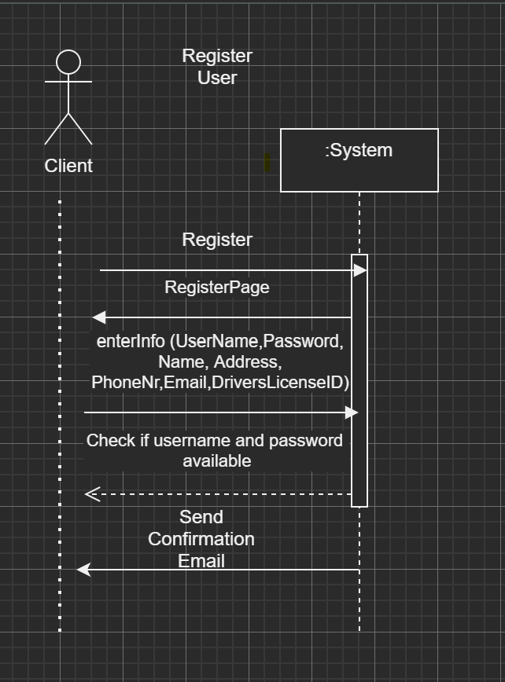

In use case 8, the client receives a mail to the email that was used to register. The email contains a button that must be pressed to complete the registration. After the successful press of a button by client, a message saying that registration was successful appears, and the system fully creates clients’ account.

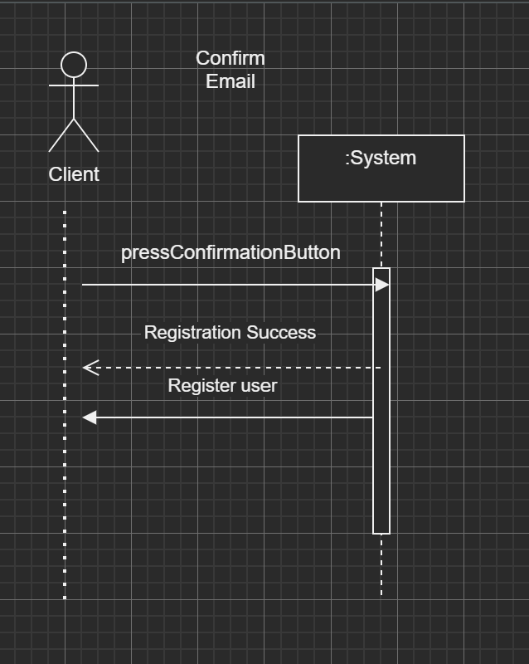

# 2.3 Prototype

A simple and quick prototype was made to gain knowledge about a system and showcase how GUI would be laid out and how it would work. The prototype showcasing the welcome screen, selection of user type and registration is shown bellow.

**Pictures of GUI**

# 2.4 ER Diagram

The Entity relation diagram is used to display the relationship of entity sets stored in database, in simpler terms the diagram helps to explain the logical structure of the database. The principle of relation database design is that the organization is based on logical relations between the data tables, the basic principle of relation databases is to make them simple and avoid duplication. By doing so the system has to handle a lot less data and the working speed is increased. For this reason the databases are dynamic and have a CRUD functionality, else the databases would run a risk of being outdated and broken due to broken relationships and data trash.